4.2.20

Region Managers,
Please share this with your sites as soon as possible and ensure that every staff member with social media access has read it. Below are new Social Media Guidelines during COVID-19, and Staff Resources has been updated with new PRHS Social Media Policies.

During this time of uncertainty, we are all having to make changes quickly. To help us present a unified message while sharing the latest information, we have decided to ask all sites to temporarily refrain from posting to all social media at this time. Instead, we will use the Division’s accounts to keep our citizens informed and inspired for future visits.

1 – Cease posting to social media.
At this time, all social media posts to all site accounts should cease, including Facebook, Instagram, Twitter, YouTube, and others. The only exception will be the scheduled educational videos approved in advance. These should be sent to Ellen Graham first. (See the Program Guidance document on Staff Resources for instructions.) Once approved, they may be posted by sites on their Facebook accounts. Do not post a notice announcing this temporary change. Marketing Unit staff will be posting important updates to your Facebook pages as information changes. You may still send inspiring and educational photos or videos to Kim Hatcher and Owen Smith to possibly be posted to the PRHS Instagram account.
You may continue to create content to be used in the future, but for now, keep these in your files. Do not post them publicly.

If your site does need to put a notice on Facebook (such as controlled burn or road closure), send the information to all three Marketing Unit staff below. We will ensure that the information is posted.
Kim Hatcher – kim.hatcher@dnr.ga.gov
Colby Moore – colby.moore@dnr.ga.gov
Owen Smith – owen.smith@dnr.ga.gov

2 – Create Facebook direct messages.
Many sites are seeing an increase in customers sending direct messages via Facebook Messenger. To help create a consistent message, please create a temporary auto-reply for messages sent to your site’s Facebook page. Instructions are below.

Message:

- Go to your page and click inbox, it is in the top left corner of the screen.
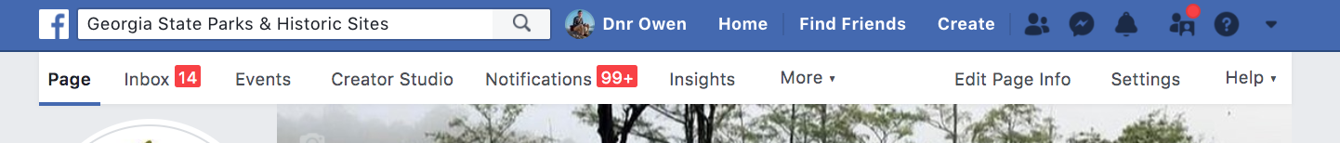

- On the left side of your screen, click “automated responses”

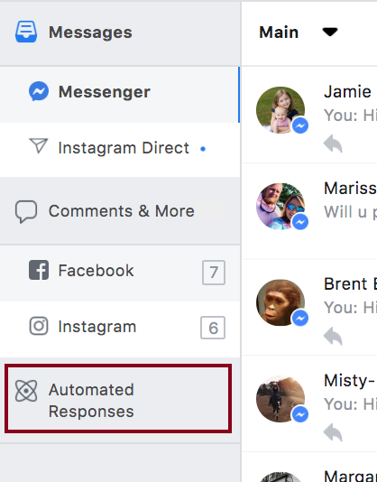

- Under instant reply, click edit.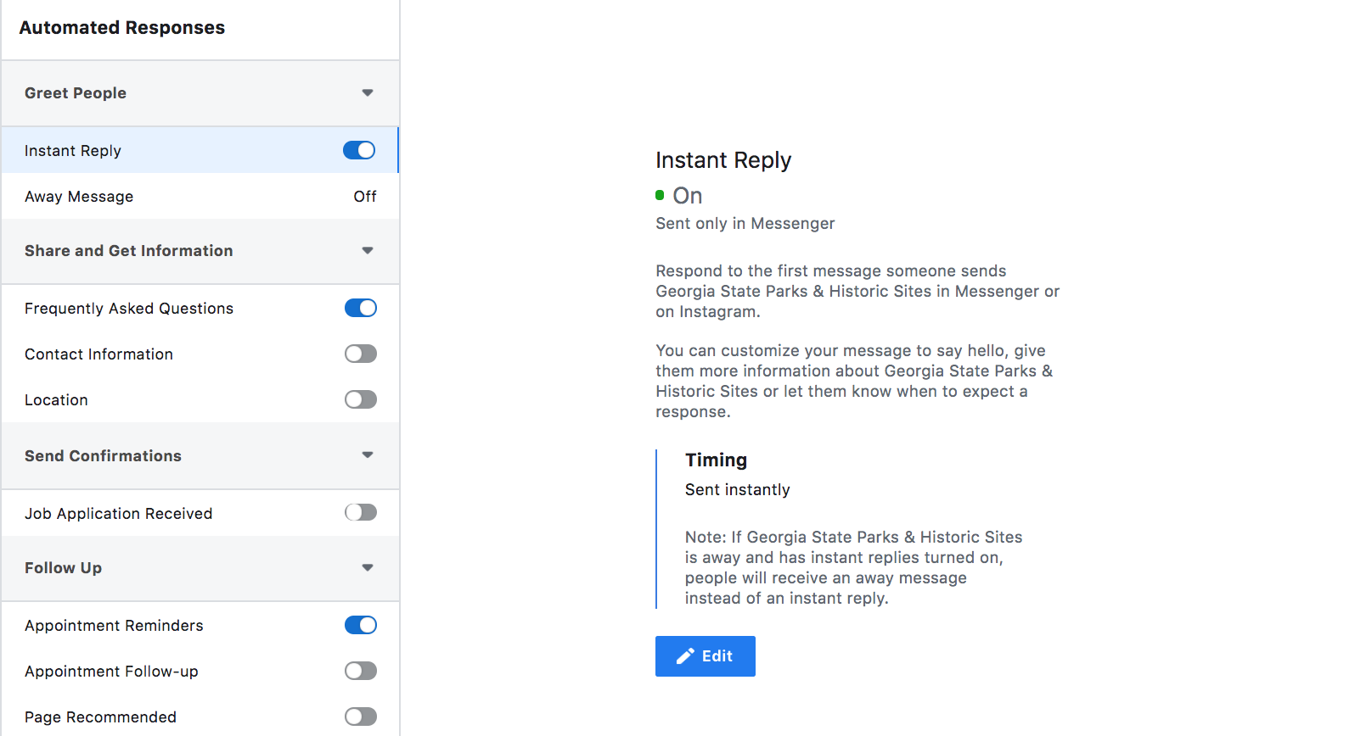

- Customize the message to say:

Thank you for contacting ____________ State Park. Currently, all campsites, cabins and trails are open to the public during our standard operating hours. Our visitor center is closed to public access, but staff remain on site to assist you. For questions about ______State Park, please call us at __________ (your phone number here). For the most current information about Georgia State Parks and Historic Sites please visit our website GaStateParks.org/alerts.

Make sure to save

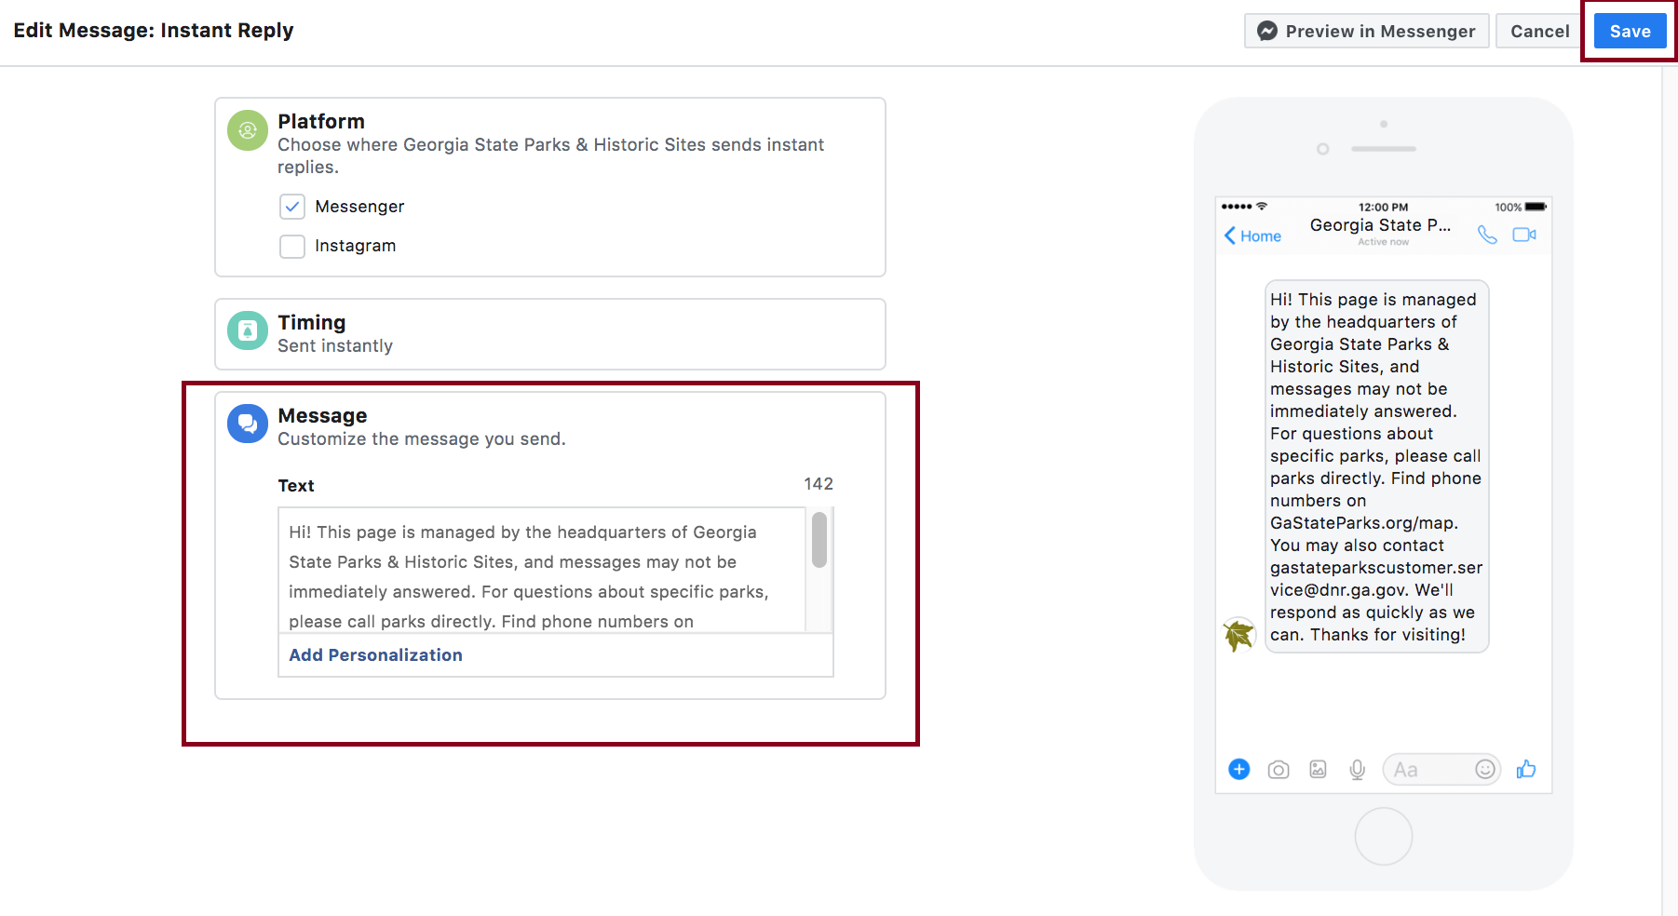

3 – Add Marketing Unit administrators to your accounts.
All sites must add administrative access to Facebook for Colby Moore, Kim Hatcher and Owen Smith. Instructions are provided below. If you have trouble adding admins, please contact Owen Smith for assistance. Managers, take this time to review and modify who else has admin access to your Facebook page. Remove those who are not employees. Since Instagram does not allow multiple administrations, send your login information to Kim Hatcher.

Facebook Instructions to Add an Administrator:
- Go to your Park’s Facebook page
- Click “Settings” in the top right
- On the left-hand side of the screen, click “Page Roles”

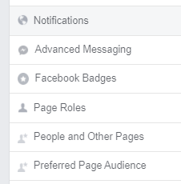

- Find “Assign a New Page Role” and change “Editor” to “Admin”

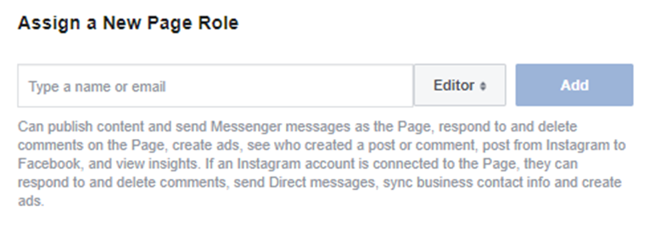
- VERY IMPORTANT! Enter the COMPLETE EMAILS of the three people below (one at a time). There are many Facebook users with these same names, so you must ensure you are picking the correct people. You are looking for these photos. In many cases, Kim and Colby will already have access to your page. Make sure these are set to Admin (not Editor). You will have to enter your password again, then Facebook will send us in Marketing a notification.

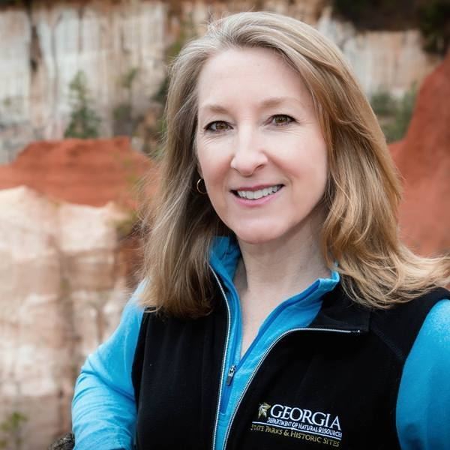
Facebook name: Kim Hatcher
Kim.hatcher@dnr.ga.gov

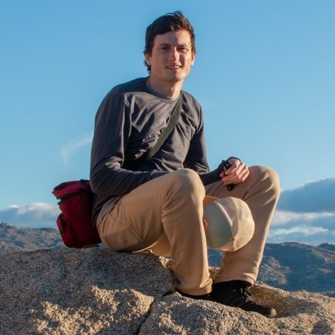
Facebook name: Dnr Owen Smith
Owen.smith@dnr.ga.gov

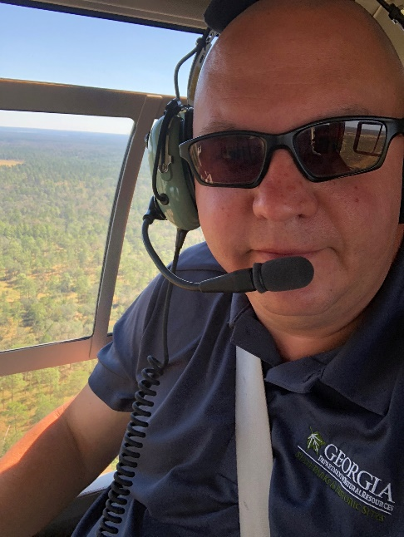

Facebook name: Dnr Colby Moore
Colby.moore@dnr.ga.gov

